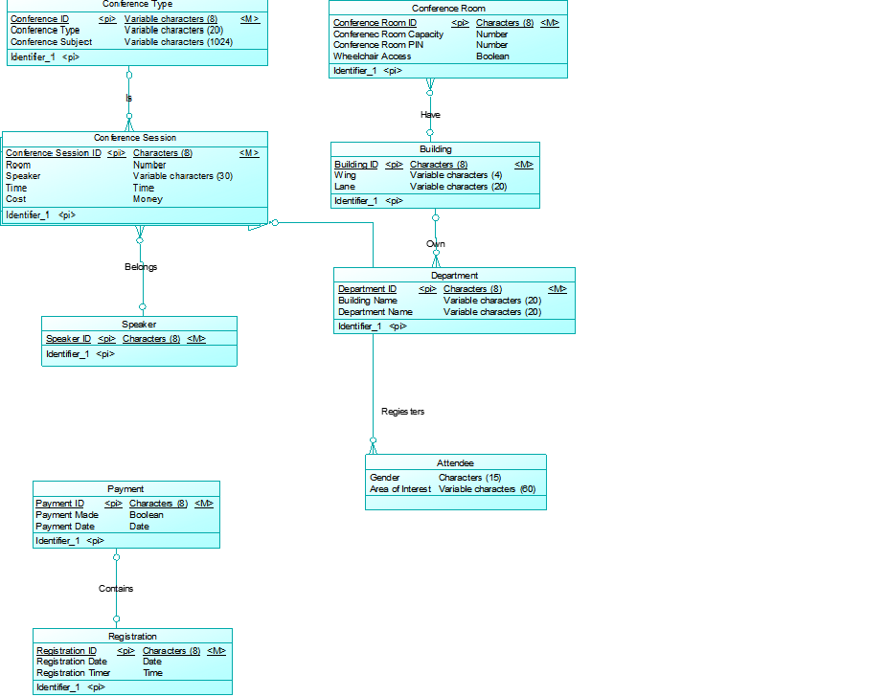 Task 1: A screenshot of the E-R diagram.

Justifications (Task 1):

1. All IDs (Conference ID, Conference Room ID, Speaker ID, Building ID, Department ID, Registration ID, Conference Session ID, Payment ID) are no longer than 8 characters.
2. The type of the conference is no longer than 20 characters (Can be either a lecture, seminar, workshop and others)
3. The subject can of the conference can be various and the maximum amount characters of such attribute is 1024 characters.
4. The data type of conference room capacity and the conference room pin are both numbers.
5. The data type of attribute “wheelchair access” is Boolean as it is either “Yes” or No”.
6. The data type of attribute “payment made” is Boolean as it is either “Yes” or “No”
7. The maximum amount of characters of both department and building name is 20.
8. The maximum amount of characters of “payment mode” is 40 characters.
9. The data type of the type of the conference cost is money – money related (currency)
10. The maximum number of characters for attendee’s area of interest is 50 characters.
11. Under the registration, I have added two new attributes, they are the registration time and date.

Assumptions:

There are six relationships in my database:

1. Conference Type - Confession Session (One-to-many relationship). It means that each conference type can have multiple conference sessions while each conference session can only have one conference type.
2. Conference Session – Speaker (Many-to one relationship). It means that each conference session may have a speaker, while a speaker can host multiple conference sessions.
3. Payment – Registration (One-to-one relationship). It means that each payment belong one (only one) registration and each registration only belongs to one payment.
4. Conference Room – Building (Many-to-one relationship). It means that a building may more than one conference rooms while each conference room only belongs to one building.
5. Building – Department. (One-to-many relationship) It means each building can more than one departments, while each department can only located at most one building.
6. Conference Session – Speaker. (Many-to-one relationship). It means that each conference session can have one speaker while a speaker can host multiple conference sessions.

Associative Entities (May include many-to many and ternary relationships

1. The entity (attendee and conference session) is an example of an associative entities as the relationship between these entities is many-to-many.

Task 2: A screenshot of the enhanced E-R Diagram



Justifications:

1. The speaker entity has been extended by adding two new entities, they are: staff and other speaker; since speaker can either its own staff (MQ staff) or speaker from other organisation. In this case, the inheritance for this entity (speaker) is total and disjoint. This is due to the fact the speaker entity must be a member of either MQ staff or other speaker; it cannot exist by its own. In terms of the disjoint constraint of the entity, it is belong to the disjoint rule as the speaker (supertype) cannot be a MQ staff and the other speaker at the same time.
2. Similarly, the attendee entity has been extended by adding three new entities, they are students, staff and other attendees. In this scenario, the complete constraint of such entity is total as the supertype (attendee) must be a member of a student, staff or other attendee. In addition, the disjoint constraint of the entity (attendee) is overlap as the supertype may simultaneously be member of two (or more) subtypes. For example, the attendee can either a PHD student or a staff (which gives of lecture to undergraduate students), therefore it’s an overlap constraint.

Task 3:



Justifications:

Composite Attributes:

1. The name of the guest speaker can be broken into “First name” + “Last name”.
2. The address of the guest speaker can be broken down into simple attributes such as “street”, “suburb”, “state”, “postcode”, “city”
3. Within the street attribute, it can break into “street name”, “street number”,
4. The attendees (student and staff) can break into “student first name”, “student last name”, “age”, “nationality”, “date of birth”, “telephone number”